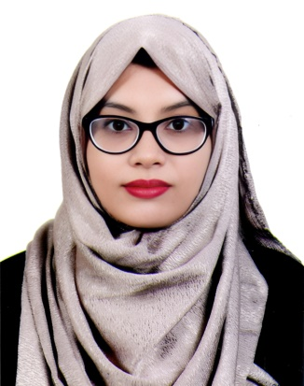
CURRICULUM VITAE
NADIA AKTHER
Abdullah Khan Road, Badurtala, Panchlaish, Chattogram.
Mobile: +8801860-916187
E-mail: nadiaakther1999@gmail.com
CAREER OBJECTIVE
To pursue a highly rewarding career, seeking for a job in challenging and healthy wok environment where I can utilize my skills and knowledge efficiently for organizational and dedication to achieve organizational as well as personal goals.
ACADEMIC QUALIFICATION
Examination : Bachelor of Science Physics
Institute : National university (Govt. city college, chattogram)
Subject: Physics (Academic Year 2018-2019)
Result : 3.17out of 4.00
Examination : Higher Secondary Certificate (H.S.C)
Institute : Hazera-Taju University College
Board : Chittagong
Group : Science
Passing Year : 2017
Result : GPA- 3.58 Out of 5.00
Examination : Secondary School Certificate (S.S.C)
Institute : Kapashgola City Corporation Girl’s High School
Board : Chittagong
Group : Science
Passing Year : 2015
Result : GPA- 5.00 Out of 5.00
COMPUTER LITERACY
Application software :
- Microsoft Office (2019)
• Internet: Internet Browsing, Send & Receive Mail & Chatting.
- Typing: English & Bengali. English-50, Bangla-30.

LANGUAGE SKILLS:
- Good command over speaking, reading and writing both in English and Bengali.

PERSONAL SKILL:
- Very good in group dealing.
- Excellent analytical ability.
- Creative in the workshop.
- Strong Presentation Skills.
- Good Writing Skills.
- High Degree of Initative.
PERSONAL INFORMATION:
Father’s Name : Late MD. Ismail
Mother’s Name : Nasima Akther
Date of Birth : 05/10/1999
Religion : Islam
Gender : Female
Marital Status : Single
Nationality : Bangladeshi
Blood Group : B+
Permanent Address : Vill: Amirabad, P.O: MasterHat-4396
P.S: Lohaghara Dist: Chittagong
EXPERIENCE:
Customer Service Officer June 2019 – Nov 2020
Elite Mart BD Ltd. GMIT Institute, Chattogram

Responsibilities:
1. Providing customer all kinds of information related to Elite products are their services.
2. Simultaneously working on a number of websites while providing information on call.

REFERENCE:
Nurnahar Begum
Professor
Department of Physics
Contact: 01719877210

Nadia Akther
Signature & Date

